NATIONAL DIPLOMA IN
COMPUTER SCIENCE

Introduction to System Analysis & Design

COURSE CODE: COM 125

Week 1
Practical Objectives:
- The student is expected to get familiar with the SSADM package that will allow him to run the various practicals
- Other methodologies will also be briefly discussed
- The meaning of SSADM, its techniques, logical modeling, data flow modeling, Entity /Event modeling
- Structure of SSADM
Introduction
In the early days of large scale information systems development many organisations used the Cobol programming language together with indexed sequential files to build systems for customer billing, payroll, stock control and a variety of other business areas. Developments at this time were characterised by :-
- limited user involvement;
- inadequate requirements elicitation;
- use of ad hoc analysis and design techniques;
- absence of CASE support for analysis and design;
- time consuming use of 3GL tools;
- inflexible file and 3rd generation database management systems.
Frequently the results of this approach were systems which, on delivery, did not satisfy business requirements. This caused extensive maintenance requirements and thus an increase in the applications backlog. A variety of problems may have caused the mis-match between system functionality and business requirements :-
- a lack of ownership of and commitment to the system from users as a result of the low level of involvement;
- business requirements may have changed between inception and delivery;
- requirements may have been mis-understood;
- inadequate analysis and design tools and techniques may have been used; • or more likely a combination of these problems.
The response from the information systems community to these problems was the development of structured methodologies for ISE. The purpose of these methodologies seems to have been to (a) formalise the requirements elicitation process to reduce the chances of mis-understanding the requirements
(b) To introduce best practice techniques to the analysis and design process
SSADM (in common with other structured methodologies) adopts a prescriptive approach to information systems development in that it specifies in advance the modules, stages and tasks which have to be carried out, the deliverables to be produced and furthermore the techniques used to produce the deliverables. SSADM adopts the Waterfall model of systems
development,(this will be discussed later in other courses) where each phase has to be completed and signed off before subsequent phases can begin. SSADM is one example of a structured methodologies, a variety of others are widely used in ISE, including :
STRADIS: (Structured Analysis, Design and Implementation of Information Systems) a methodology developed by Gane and Sarson (1979). The methodology is based on the philosophy of top down functional decomposition and relies on the use of Data Flow Diagrams.
YSM: (Yourdon Systems Method,Yourdon, 1993). YSM is similar to STRADIS in its use of functional decomposition, however a middle-out approach is dopted and slightly more emphasis is placed on the importance of data structures.
MERISE: (Quang and Chartier-Kastler, 1991)The methodology is widely used in ISE in France, Spain and Switzerland. MERISE consists of three ‘cycles’, the decision cycle, the life cycle and the abstraction cycle. The abstraction cycle is the key, in this cycle both data and processes are viewed firstly at the conceptual level, then the logical or organisational level and finally at the physical or operational level.
EUROMETHOD: (CCTA, 1994) Euromethod could be described as a framework for the integration of existing european methodologies rather than as a methodology in its own right.
What is SSADM?
SSADM (Structured Systems Analysis and Design Methodology) is a methodology ( i.e a system of ways of doing things especially regular and orderly procedures), used in the analysis and design stages of systems development. SSADM does not cover SITP issues or the construction, testing and implementation of software.
"SSADM has been used by in computing since its launch in 1981. In a bid to standardise the many and varied IT projects being developed . Since 1981 SSADM has been further refined and version 4 was launched in 1990. SSADM is an open standard, i.e. it is freely available for use in industry and many companies offer support, training and Case tools for it.
Why is SSADM Used?
Within government departments SSADM has to be used. External contractors producing software for the government also have to use SSADM. SSADM is used by other companies because they expect the use of a disciplined ‘engineering approach will eventually improve the quality of the systems they produce. many companies have been willing to incur the considerable expense of implementing SSADM (e.g. staff training) with this expectation in mind.

Major Tools of SSADM?
SSADM revolves around the use of three key techniques, namely
- Logical Data Modeling,
- Data Flow Modeling • Entity/Event Modeling.
Logical Data Modeling; This is the process of identifying, modeling and documenting the data requirements of a business information system. A Logical Data Model consists of a Logical Data Structure (LDS - The SSADM terminology for an Entity-Relationship Model) and the associated documentation. LDS s represent Entities (things about which a business needs to record information) and
Relationships (necessary associations between entities)
Data Flow Modeling; This is the process of identifying, modeling and documenting how data flows around a business information system. A Data Flow Model consists of a set of integrated Data Flow Diagrams supported by appropriate documentation. DFDs represent processes (activities which transform data from one form to another), data stores (holding areas for data), external entities (things which send data into a system or receive data from a system and finally data flows (routes by which data can flow)
Entity Event Modeling; This is the process of identifying, modeling and documenting the business events which affect each entity and the sequence in which these events occur. An Entity/Event Model consists of a set of Entity Life
Histories (one for each entity) and appropriate supporting documentation. slide 9

Structure of SSADM
SSADM consists of 5 main modules, which are in turn broken down into a complex hierarchy of stages, steps and tasks. slide 11
- Feasibility Study; Module 1 the feasibility study consists of a single stage (Stage 0 Feasibility),which involves conducting a high level analysis of a business area to determine whether a system can cost effectively support the business requirements. In stage 0 an overview DFD is produced together with a high level LDS. At this stage the DFD will represent the existing system warts and all and the LDS may be incomplete and contain unresolved M:M relationships.

- Requirements Analysis; Module 2 requirements analysis consists of 2 stages;

Stage 1 Investigation of Current Environment and Stage Business System Options (BSO).

During stage 1 the systems requirements are identified and the current business environment is modeled in terms of the processes carried out and the data structures involved. During stage 1 DFDs and an LDS are used to produce detailed logical models of the current system . During stage 2 up to 6 business system options are produced and presented. As a result one of these options (or indeed a hybrid solution) is adopted and refined. During stage 2 DFDs and LDS are produced to support each business system option and the final chosen option. The transition from stage 1 to stage 2 is a key part of SSADM, this is where we move from a logical model of the current system to a logical model of the required system, i.e. this is where the DFDs and LDS have to be refined to cater new/changed requirements.
- Requirements Specification; Module 3 Requirements Specification consists of a single stage (Stage 3 Definition of Requirements) which involves further developing the work carried out in module 2, detailed functional and non-functional requirements are identified and new techniques are introduced to define the required processing and data structures. In stage 3 the DFDs and LDS are refined and cross validated in the light of the chosen business system option. The LDS is enhanced using relational data analysis (normalisation). The DFDs and LDS are validated against the ELHs also produced during this stage. DFDs LDS and ELHs are used as input to the subsequent stages of SSADM.

- Logical System Specification; Module 4 Logical System Specification consists of 2 stages; Stage 4 Technical System Options and Stage 5 Logical Design. In stage 4 up to 6 technical options (specifying the development and implementation environments) are produced, one being selected. In stage 5 the logical design of update and enquiry processing and system dialogues (menus etc.) is carried out.

- Physical Design; Module 5 Physical Design consists of a single stage (Stage 6 Physical Design) in which the logical system specification and technical system specification are used to create a physical database design and a set of program specifications.

WEEK 4 Practical

After few explanations by the teacher, the student is required to understand the following flow charts:

Perfect Flowchart Examples!
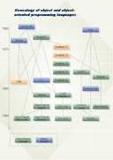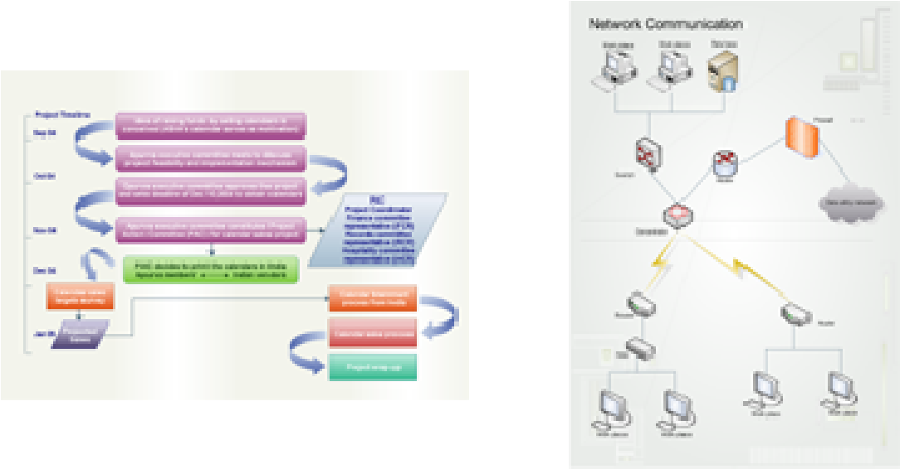

Basic Flowchart Business Process Diagram Network Diagram
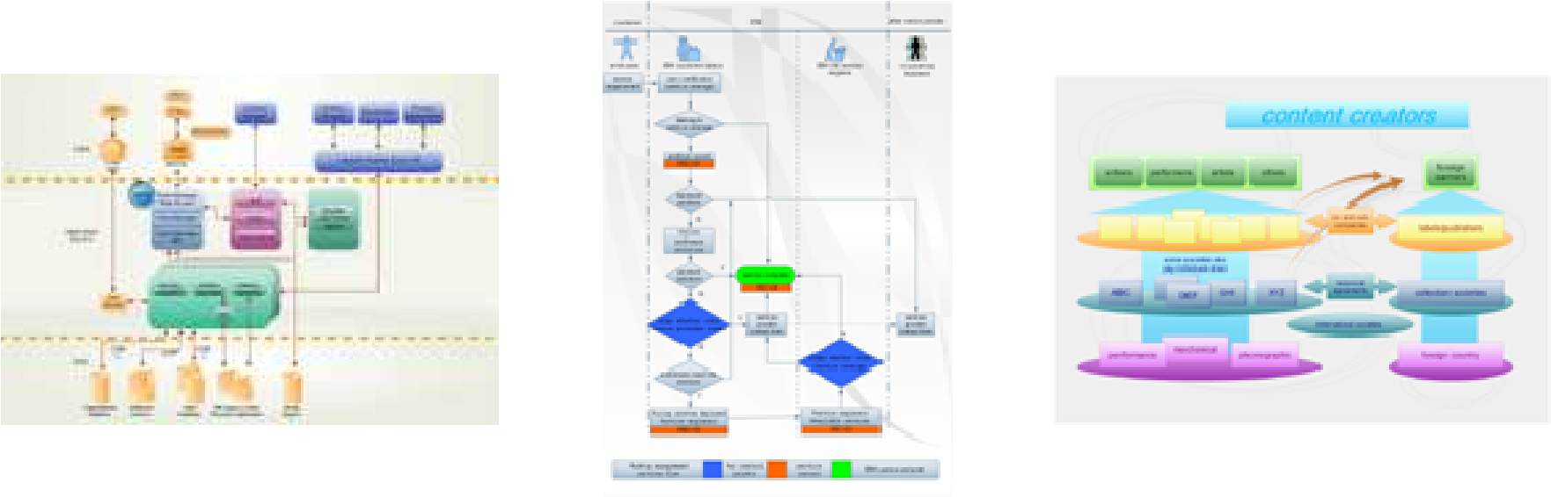

Data Flow Diagram Work Flow Business Chart
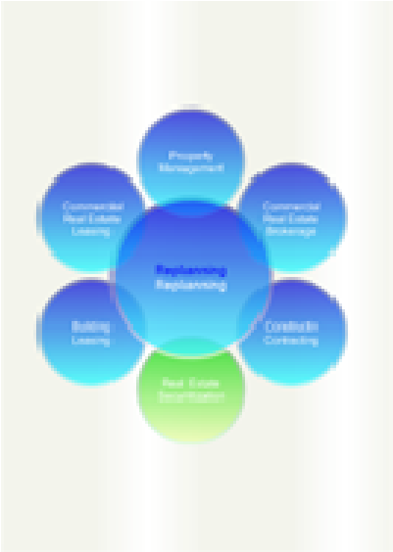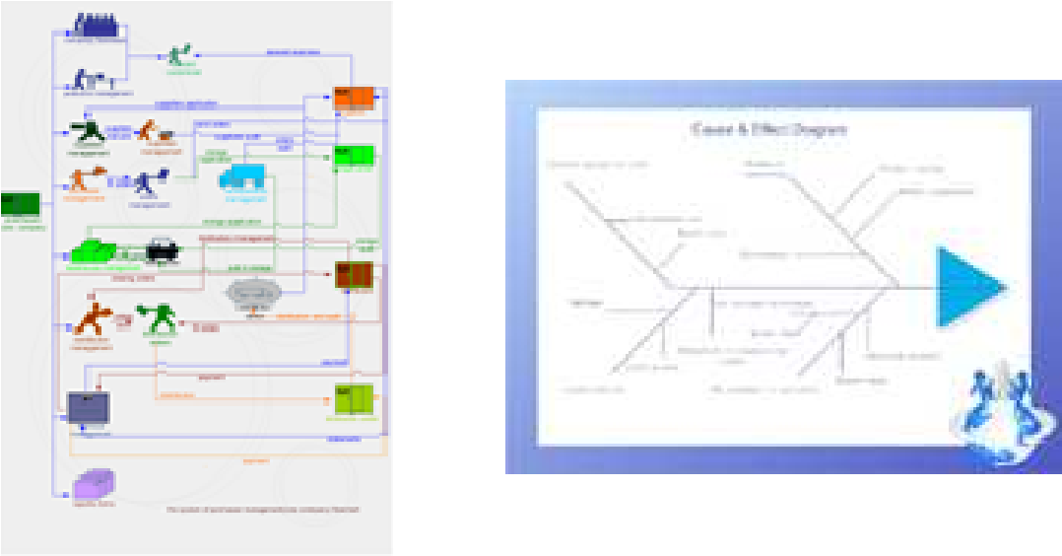
Planning Diagram Sales Flowchart Cause & Effect Diagram
Here the student is expected to practice the following:
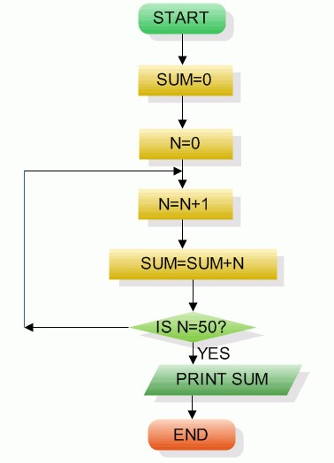
Fig. Sum of first 50 natural numbers

Flow Chart Example 2
Draw a flowchart to find the largest of three numbers A, B, and C.
Answer: The required flowchart is shown in Fig 2
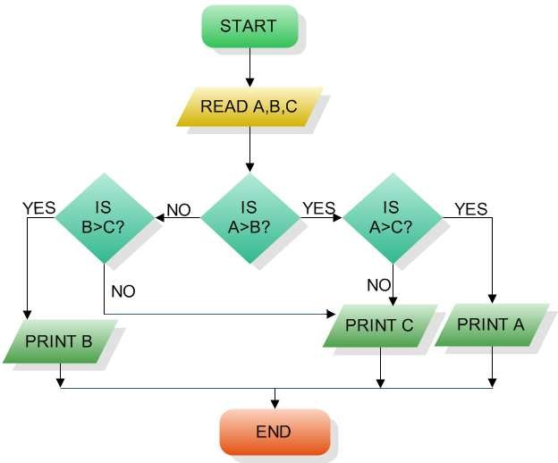

Fig : Flowchart for finding out the largest of three number

Flowchart Example 3
Draw a flowchart for computing factorial N (N!)
Where N! = 1?2?3?....N .
The required flowchart has been shown in fig 3
Answer:
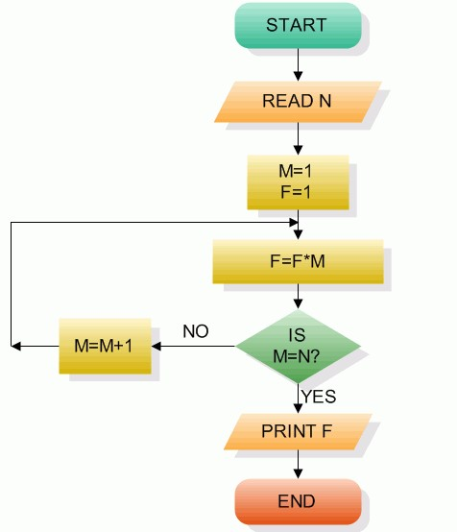
Fig 3 Flowchart for computing factorial N

WEEK 5 Practicals
In continuation of the flow chart familiarization and drawing, the student is expected to practice the following:
Understand the problem below and try to design a flow chart for it

A product assembly team in a gaming machine manufacturer were looking for ways of building the product more efficiently. They broke down the assembly process into a set of Flowcharts, showing how sub-assemblies were made and then built into the final product. Analysis of the reel assembly process revealed two improvements:
- The kit of parts was already checked by the kit assembly line, who were sometimes careless, as they knew the kit would be rechecked. The assembly line process was improved so the check here could be removed. This saved over two minutes per reel in checking, and up to fifteen minutes when the kit was faulty.
- Fitting the reel band after the reel had been attached to the base was awkward. Fitting the band before the reel was attached to the base was more comfortable and saved about a minute per reel.
Draw the process Flowcharts, before and after improvement
This flow chart is shown below and must be practiced by the students
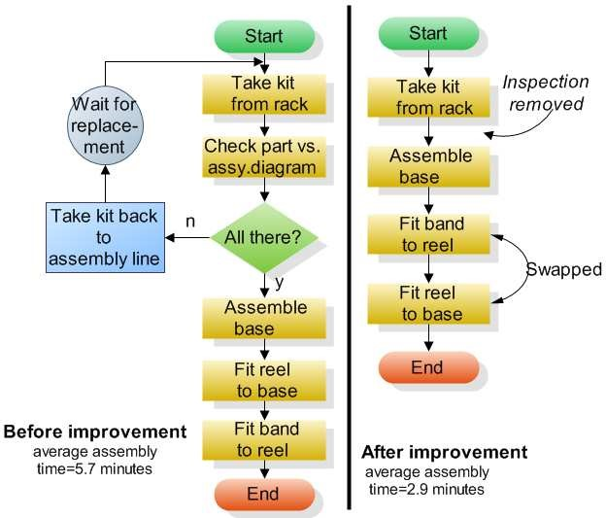

Fig Flowchart for gaming machine manufacturer

WEEK 6 – 8 PRACTICALS
The student is expected to study and understand the following example of an Organisational Chart and attempt the tutorial thereafter.
Example of Organizational Chart
Recommend a new flowchart software similar to Visio, Support flowcharts, organizational charts, business charts, UML diagrams, database & ERD, directional map and network diagrams. Easy-to-use drawing tools, many pre-drawn flowchart templates, more than 2000 symbols and examples, create flowcharts and business diagrams with minimum time loss.
How to make an organizational chart? How indeed does one go about it, without seeing and example of organizational charts? Except one has a good example of an organization chart it may be difficult to grab it.
With Edraw Organizational Chart, you can create clear and comprehensive organizational charts with no prior experience. As you can see by studying the examples of organizational chart below, these types of charts are the ideal way to illustrate the inner structure and hierarchy of a business or any other type of organization.
Nothing is left unclear when structural relationships are illustrated with an organizational chart created with Edraw - the ultimate organizational chart software. Use it to create Organizational charts, visualize company organizational chart, business organizational chart, bank organizational chart, corporate organizational chart school organizational chart and government organizational chart simples etc.

Perfect Organizational Chart Examples
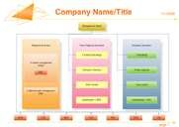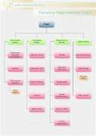

Business Organizational Company Organization
Photo Organizational Chart

Chart Chart
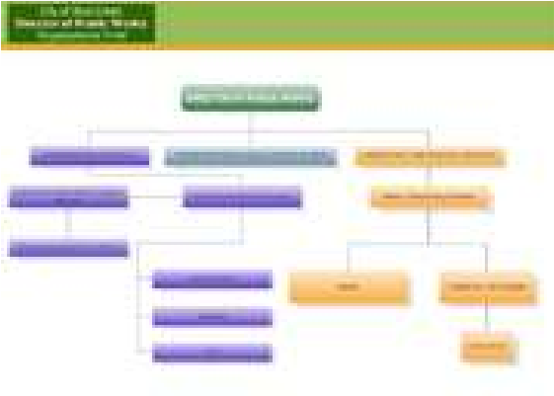

City Organizational Chart | Market Organizational Chart | IT Organizational Chart
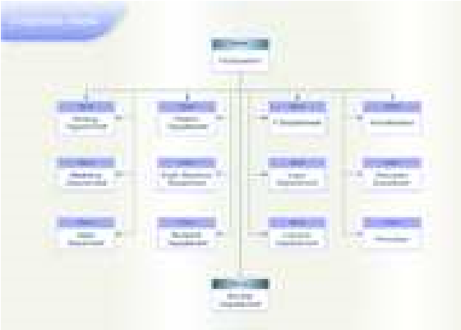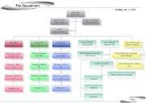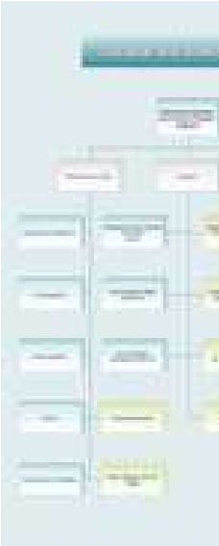

Corporate Organizational  Human Resource Org Chart Chart | School Organizational Chart
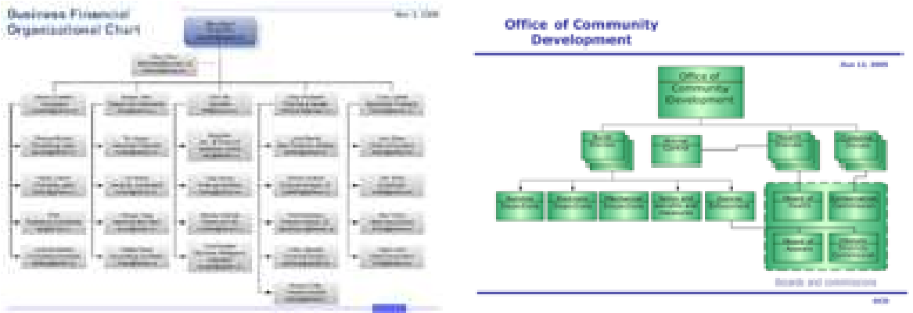
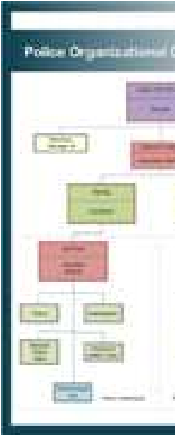

Financial Organizational  Team Organizational Chart  Chart | Police Organizational Chart

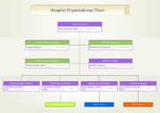

Hospital Organizational Chart

Organizational Chart Tutorial
Using Edraw to Create Organizational Charts
The tutorial explain how to create organizational charts using Edraw. The easiest way to draw a new organizational chart based on the Edraw organization chart templates and examples.
What does Edraw Organizational Chart do?

Edraw Org Chart is an organizational Chart diagramming program that can help you create business and technical diagrams that document and organize complex ideas, processes, and systems.

Interface
Edraw's toolbars contain buttons you can use to issue commonly used commands. To find out what each button does, float your mouse pointer over (do not click) the button.
- Edraw Screenshot
- Organizational Chart Templates
- Organizational Chart Examples

Creating the Organization Chart
You can open the organizational chart template for the library menu. It includes Frame Shapes, Card Shapes, Photo
Shapes, People Shapes and Custom Shapes. Library > Organizational Chart > Frame Shapes

Drag the Executive icon to your chart. After you create the new drawing, create the organization chart by dragging shapes from the stencil to the drawing page. An organization chart shape contains the name and title of the person represented by the shape.

Organization Chart Shapes
- Single Entries
- Executive - highest position
- Manager - box is similar to Executive but smaller, double lines
- Position - single line box
- Consultant - box with dashed lines
- Vacancy - box with dotted lines
- Assistant - dark single line that typically goes to the right of the Executive or manager box

Adding Multiple Shapes

You can add more than one shape of the same type to your organization chart. For example, you might need five Manager shapes under an executive shape. You can insert all the Manager shapes by dragging the Multiple Shapes shape over the Executive shape. When you do this, the Add Multiple Shapes dialog box appears in which you specify the number and type of shapes to be inserted.
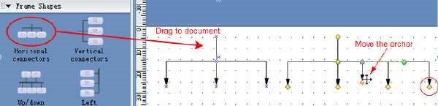
In Edraw, users create org charts by starting at the top and moving to the bottom. So the first shape added usually represents an executive. However, the topmost shape could represent a manager or project leader if the user is creating an org chart for a single department or team.

Modify Layout Options
You can use the follow two toolbars to layout shapes easily. You can also use the automation align function while you dragging.
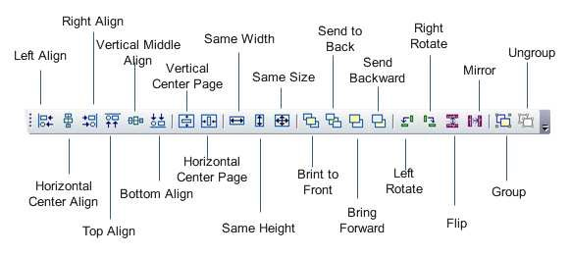
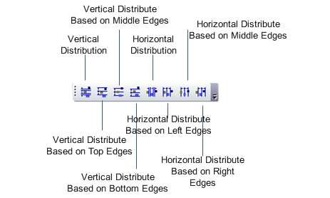

Edit Text
Very many pre-defined shapes have multiple text boxes. You can click the text region to edit every one. You can use the "Text Block Tool" to change their position too. See how to edit text.

Replace Image
All the images in the Photo Shapes can be replace with a local image file. Firstly select a photo shape then click the "Replace Photo" item in the context menu.

